## Composed Looks

**Lab Time**: 45 minutes

**Lab Folder**: C:\Student\Modules\SharePointBrandingAssets\Lab

**Lab Overview**: In this lab you will get hands-on experience working with Composed Looks.

### Exercise 1: Changing the Logo of a Team Site

In this exercise you will change the logo in your team site from the SharePoint logo to the Wingtip logo.

1. Open up <http://intranet.wingtip.com> in Internet Explorer.
2. In the **Site Actions** menu, select **Site Settings**.

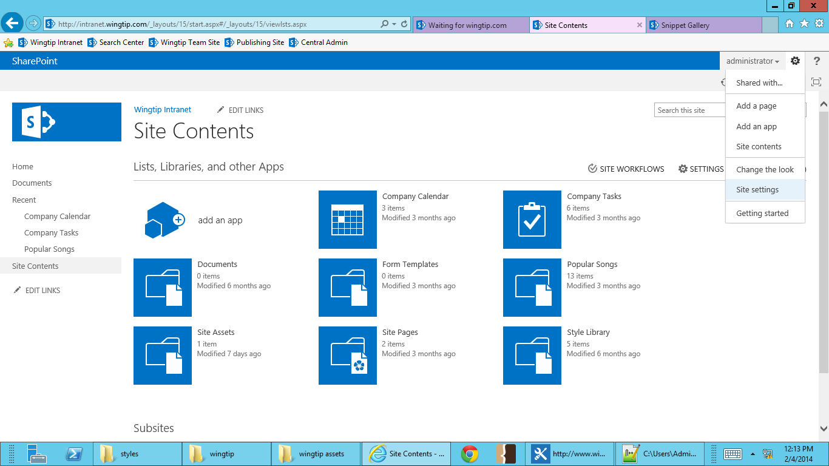

1. **Under Look and Feel, select Title, description, and logo.**

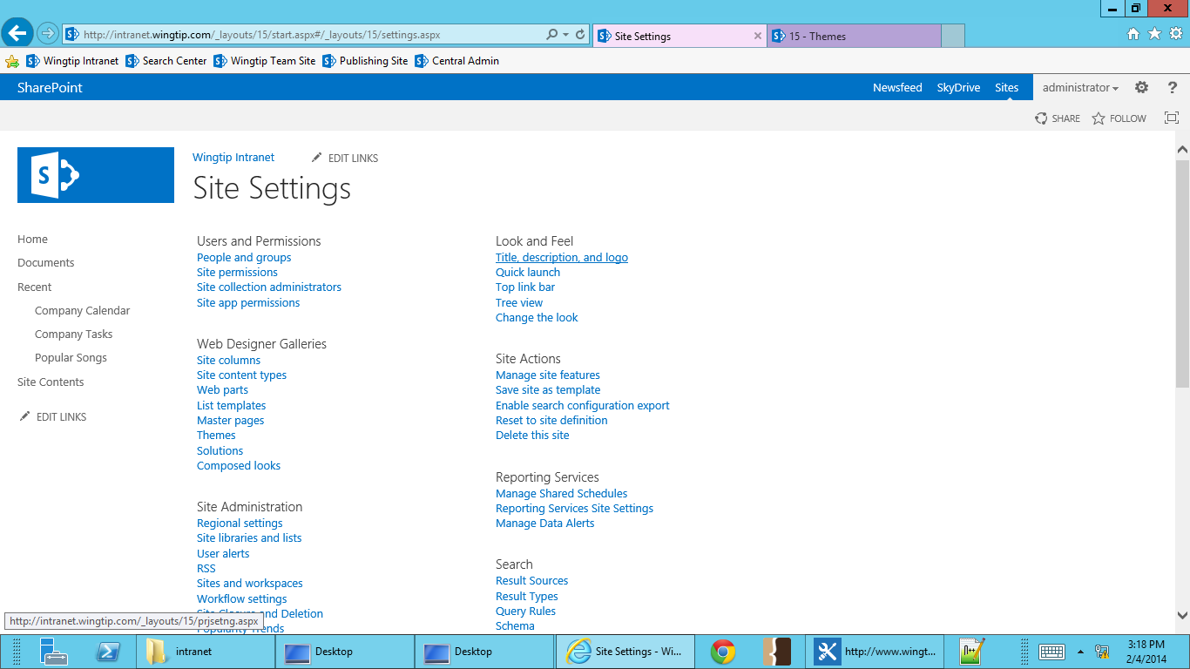

1. **Under Insert Logo, select FROM COMPUTER.**

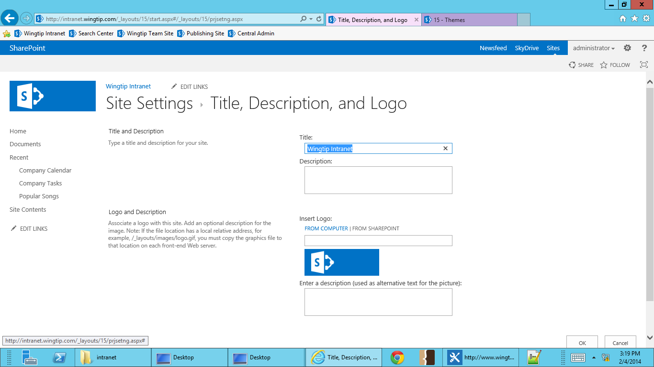

1. Browse to **logo.png** in your Student Files (\ExtraStudentFiles\DesignManagerMasterPages\styles\images\wingtip-logo.png) and upload it to your site. Select **OK**.

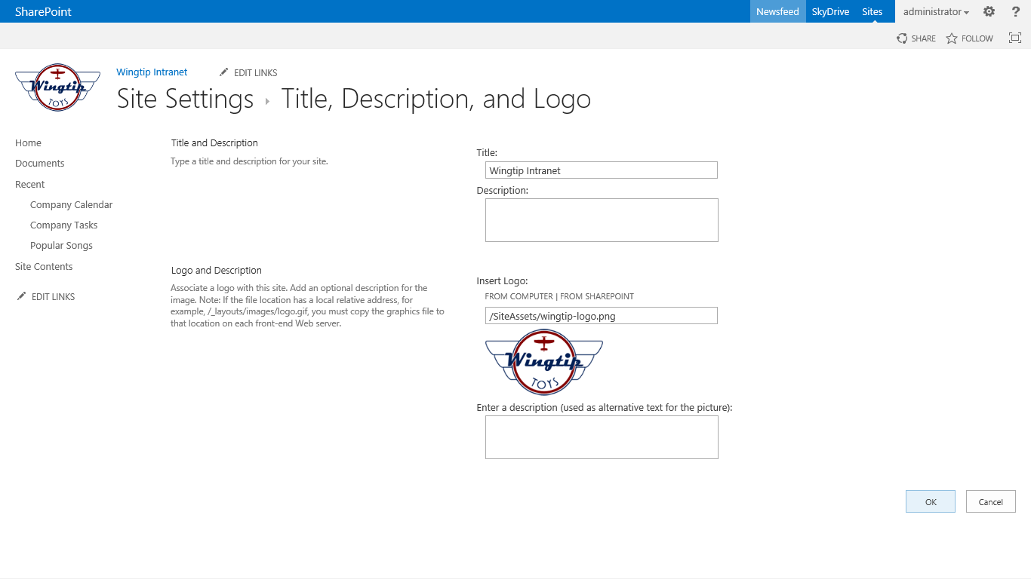

1. The Wingtip logo has now been applied to your site.

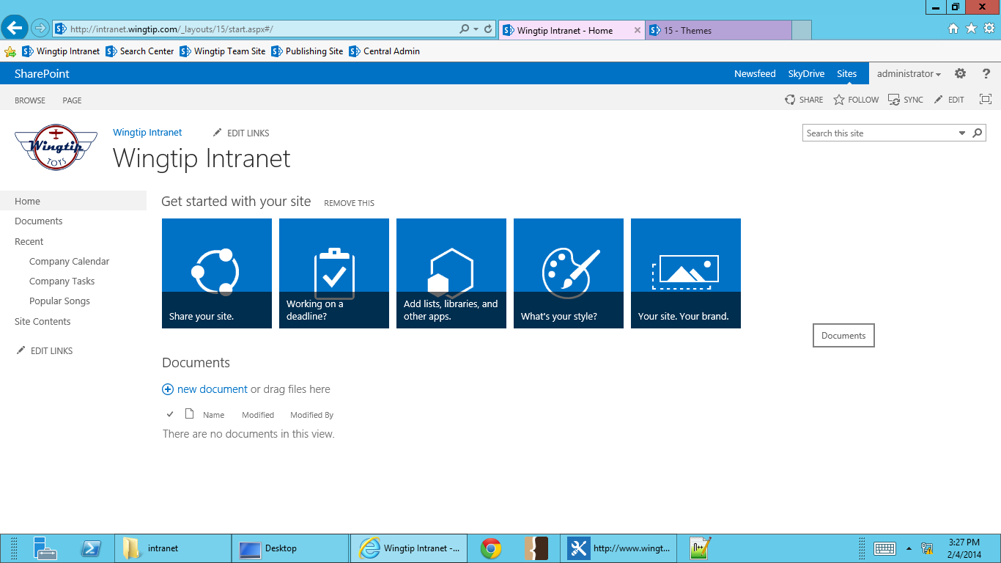

### Exercise 2: Modify an OOB Composed Look

In this exercise you will modify an OOB Composed Look by changing its font and color schemes, and adding a background image.

1. Open up <http://intranet.wingtip.com> in Internet Explorer.
2. In the **Site Actions** menu, select **Change the Look**.

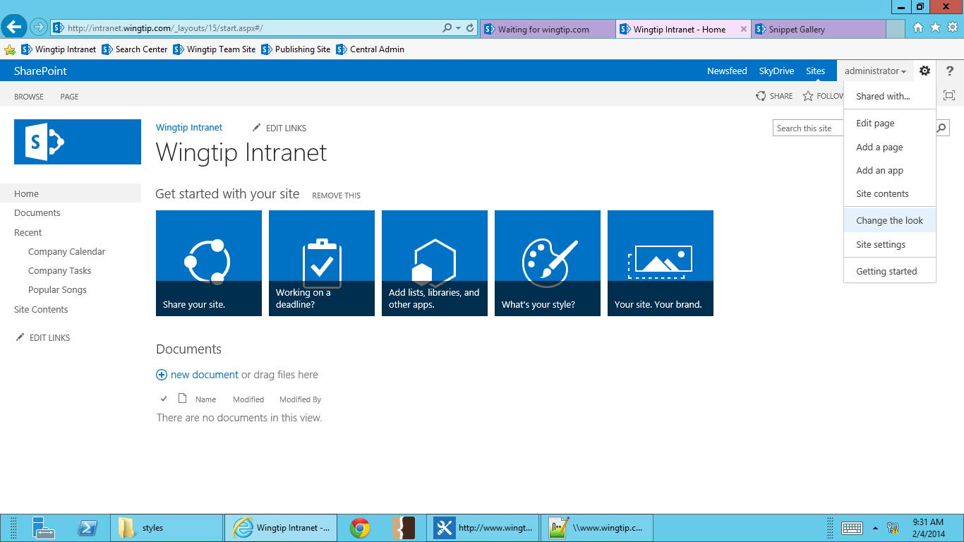

1. **You’re now in the Composed Look Gallery. Select the Orange look.**

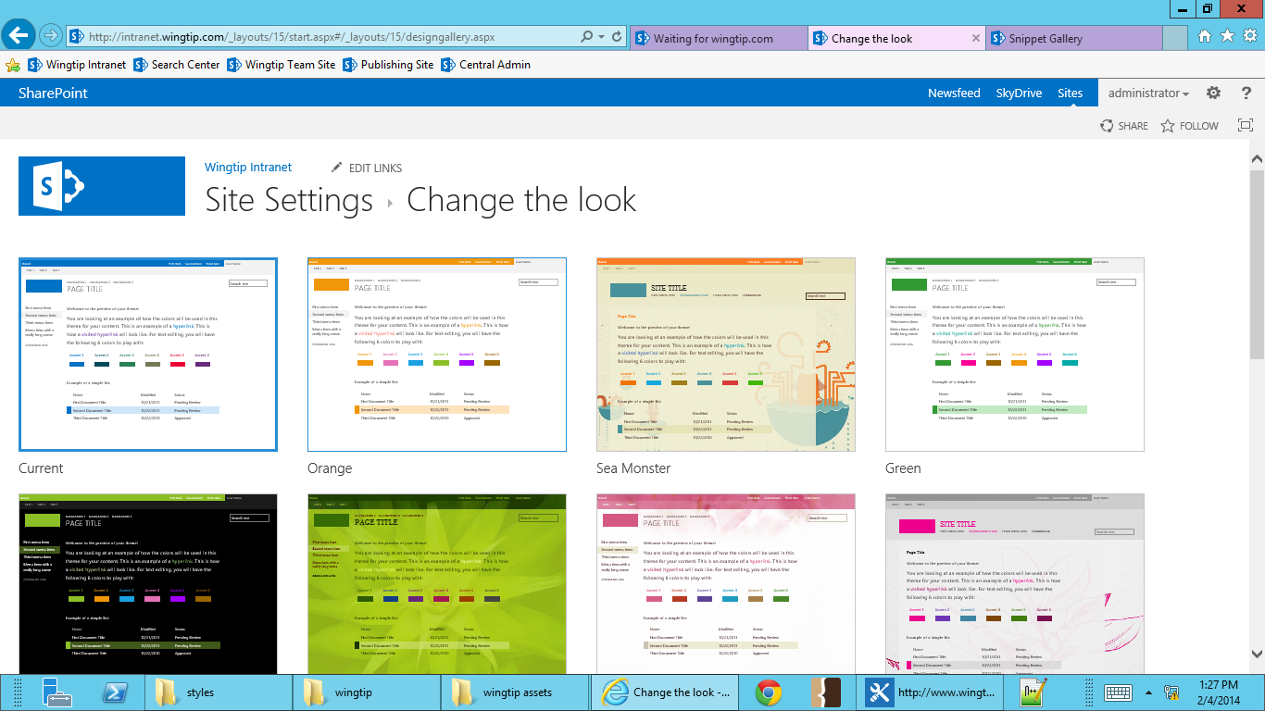

1. **On the left, you’ll see all your Composed Look modification options. Open your student files folder, find intranet-bg.jpg, and drag-and-drop it on Drop an Image Here.**

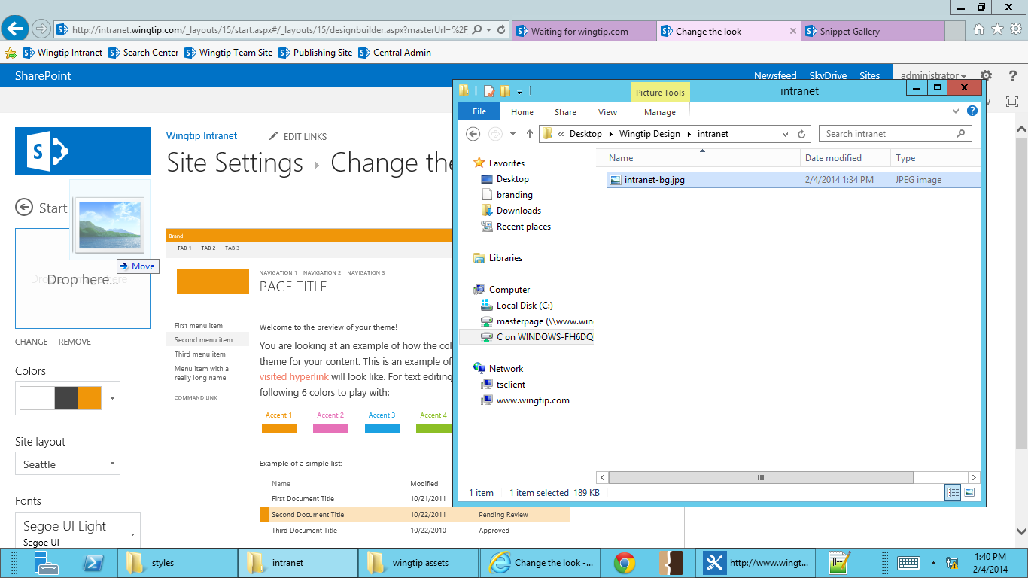

1. **From the Colors dropdown menu, select white, gray, and red.**

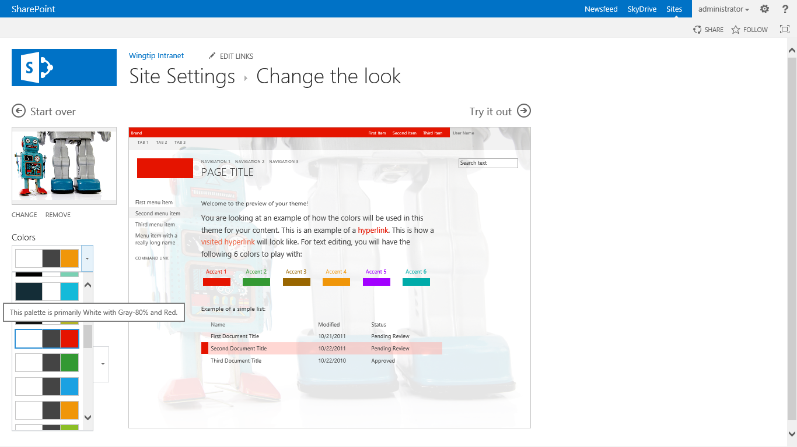

1. The **Site Layout** option is where you can change the master page. From the **Site Layout dropdown menu**, select **Oslo**.

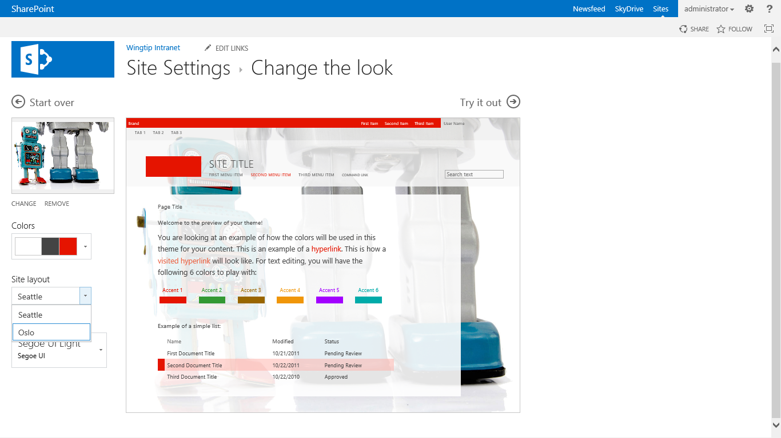

1. From the **Fonts dropdown menu**, select **Rockwell Light, Segeo UI**.

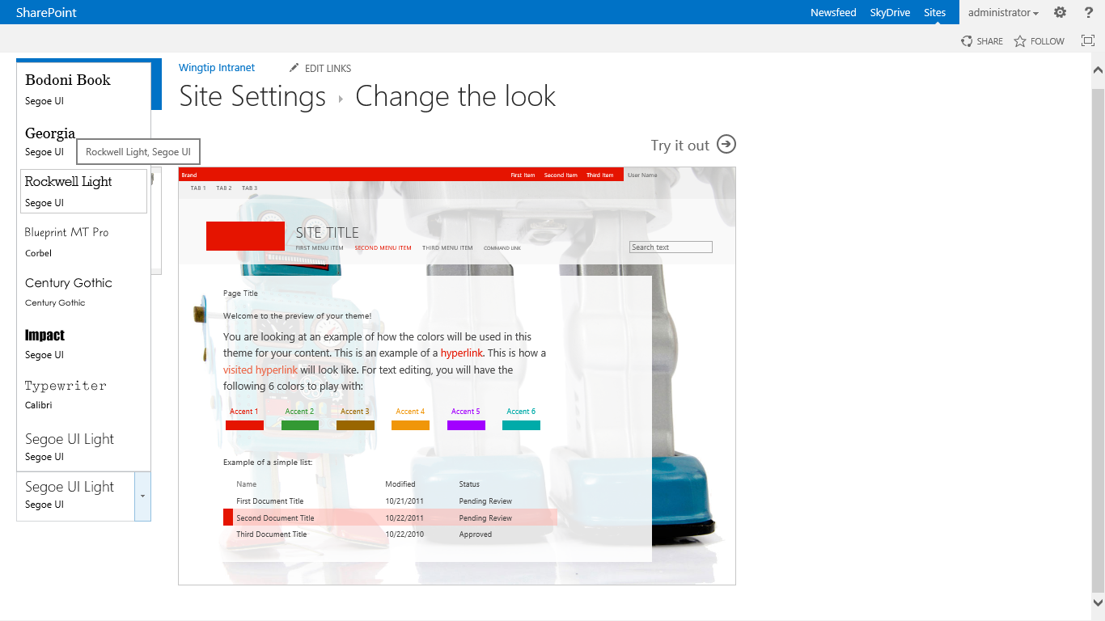

1. Select **Try it out** to preview the modified theme with your content.

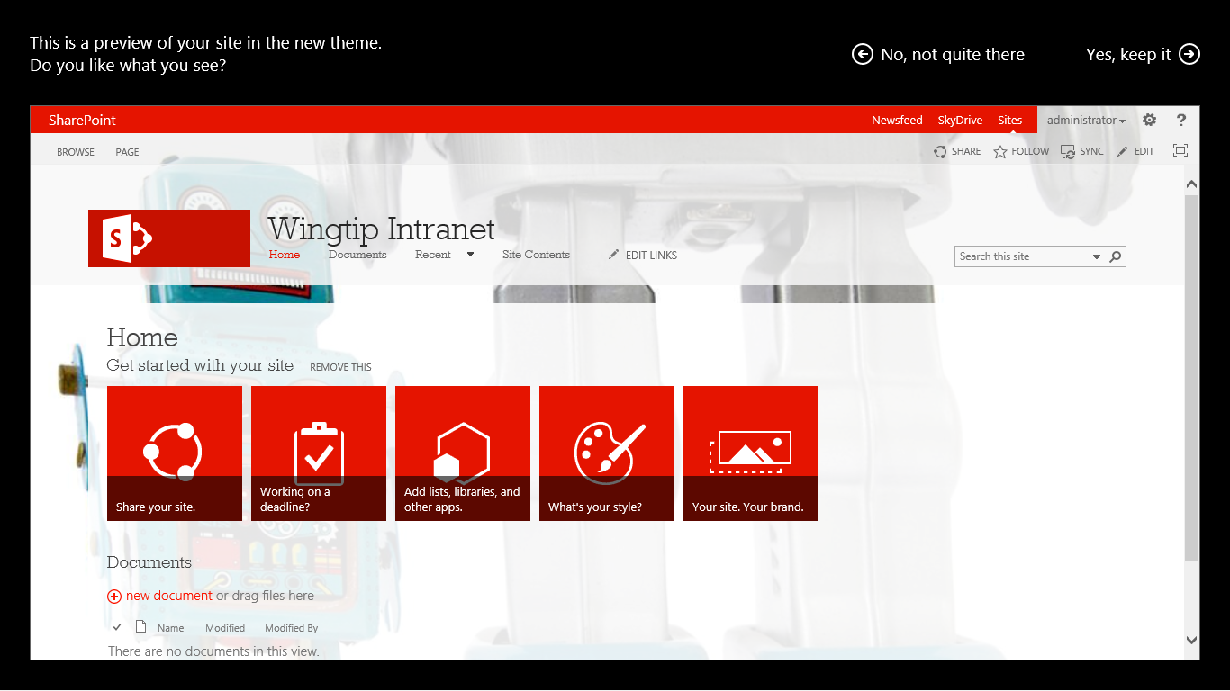

1. Select **Yes, keep it** to apply the changes to your intranet site.

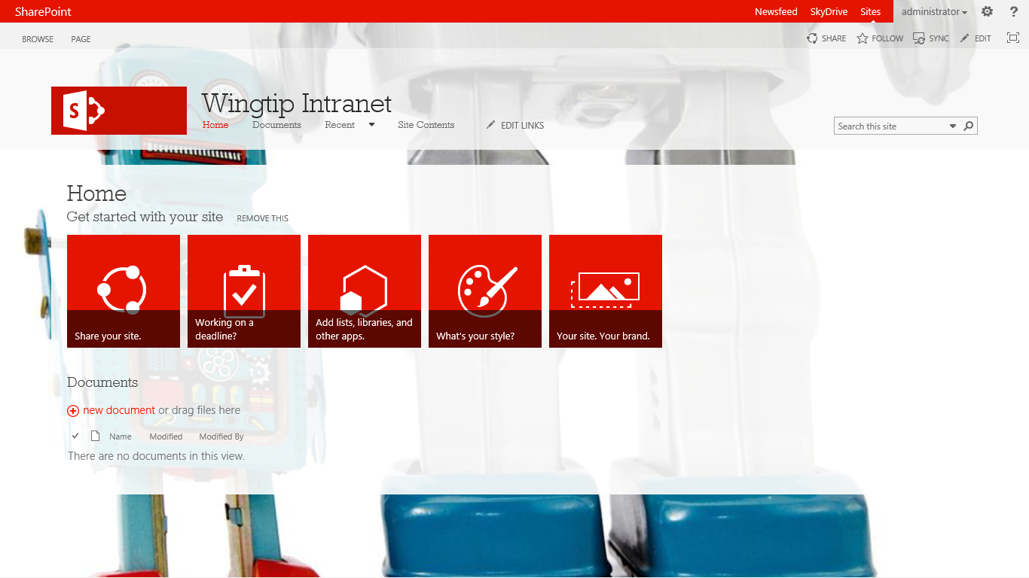

### Exercise 3: Create a Custom .spcolor File

In this exercise you will create a custom .spolor file using SharePoint Color Palette Tool.

1. Open up the SharePoint Color Palette Tool. The tool will open with the .spcolor file from the Office Composed Look, the default look, open.

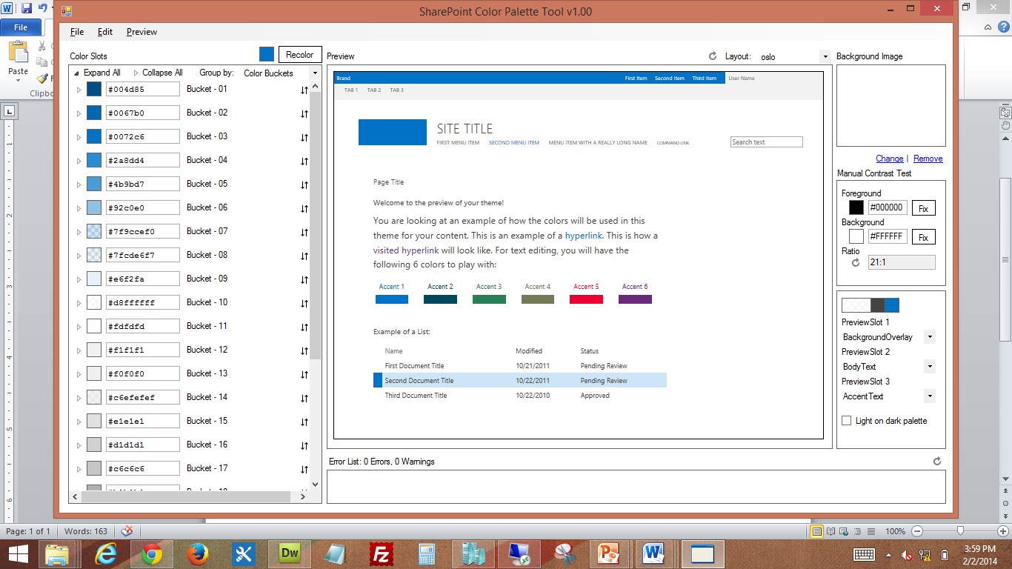

Some of the hex colors are 8 characters, instead of 6. These hex colors have an added opacity value. The first 2 characters in the color set the opacity, the last 6 are standard hex color.

1. There are multiple ways you can view the list of colors. To change the list organization, click on “Color Buckets,” in the top right of the left pane. You can view the color buckets by bucket order, UI groups, or UI type. Select “UI Groups.”

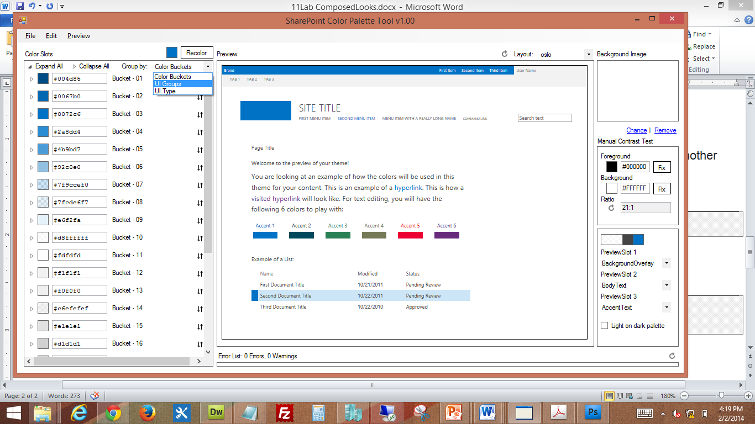

1. There are also a few ways you can enter in the desired colors. First, you can simply overwrite the current hex color with another hex color.
   1. Click the arrow to the left of the blue box for **12.- Content Accents**.

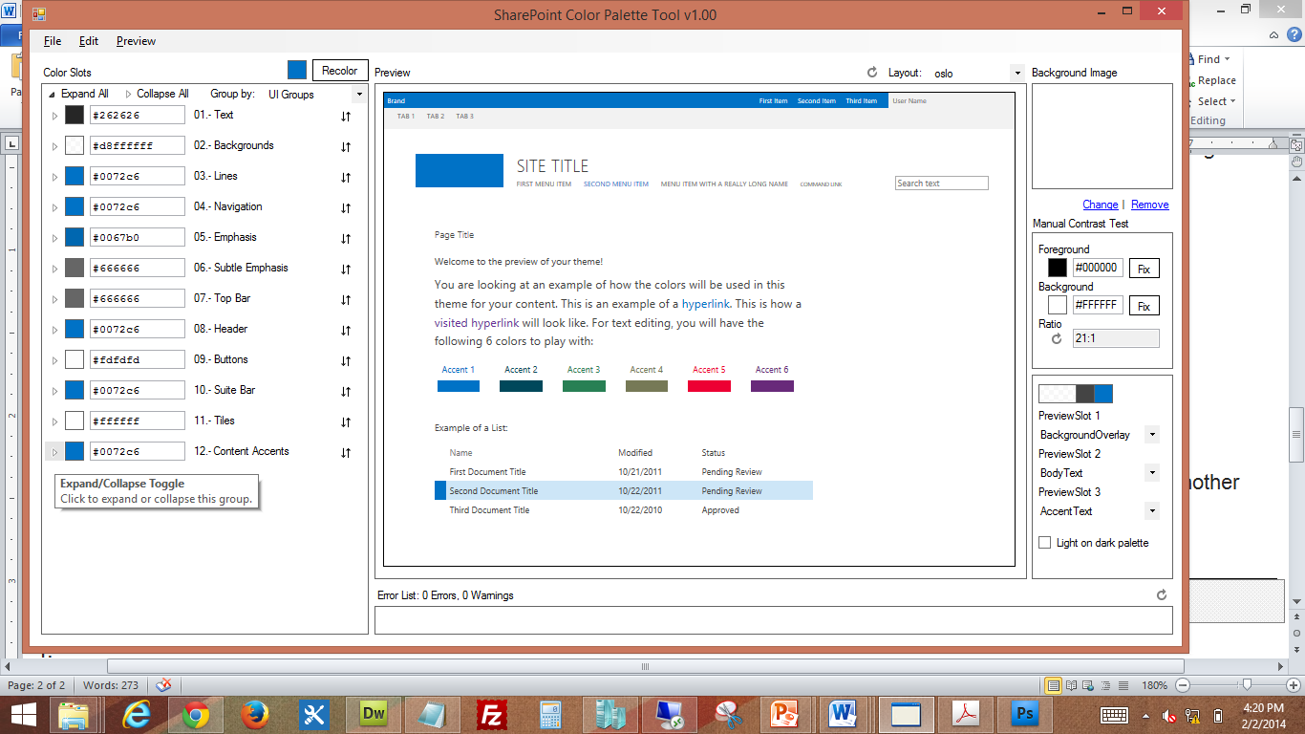

* 1. Change the hex color for **Content Accent 1** from **#0072c6** to **#002157**. Note that as you change hex color, the color of the box next to the hex, as well as the Accent 1 section in the preview pane immediate change to your new color.

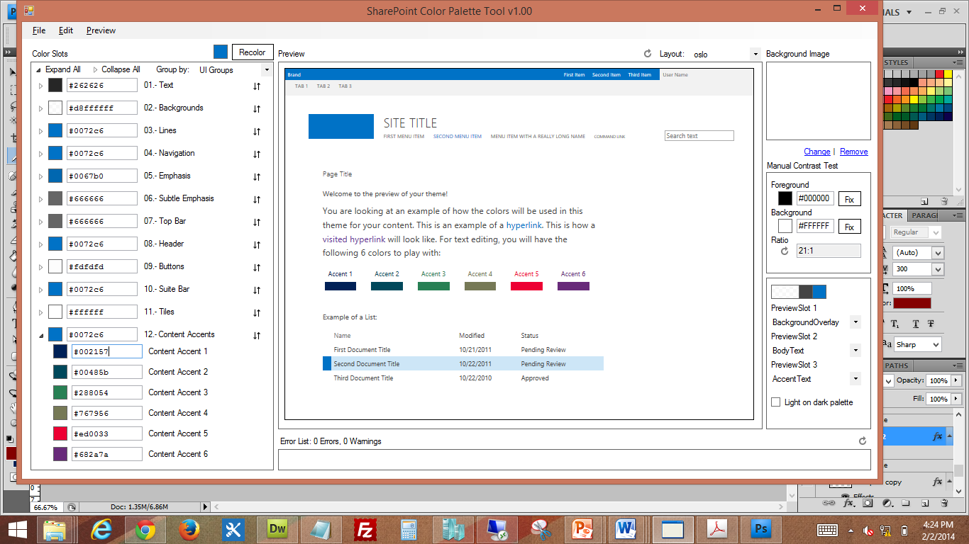

1. Another way to change the color in a color slot is by using the color picker. With the color picker you, you can enter RGB, HSL, or select a color with the dropper tool. The color picker also has an option to set opacity.
   1. To access the **color picker** tool, click on the colored box to the left of **Content** **Accent 2**.

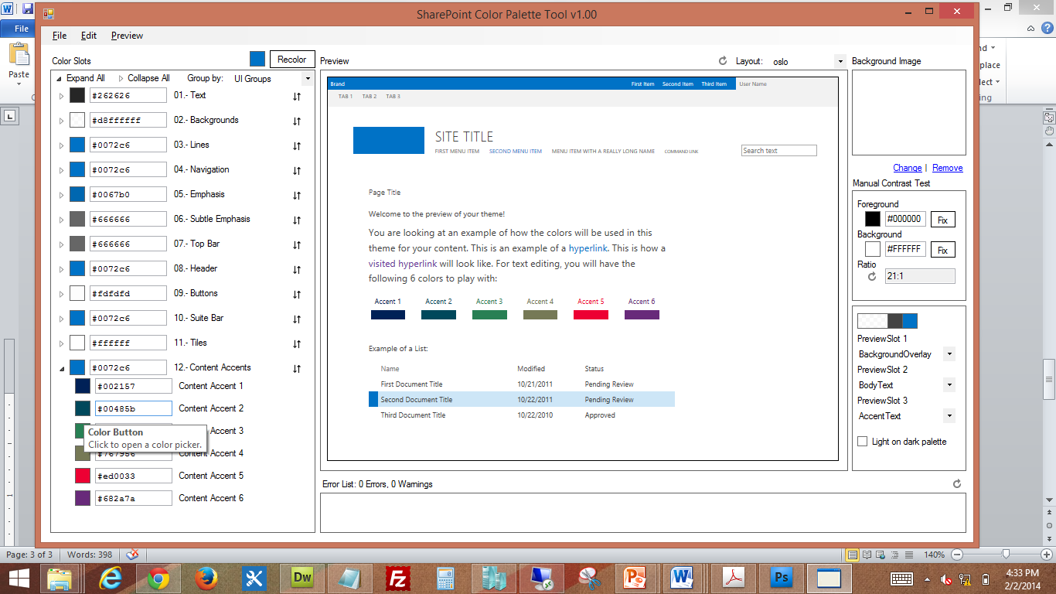

* 1. Enter the RGB color: **R 132, G 0, B 0** and select **OK**.

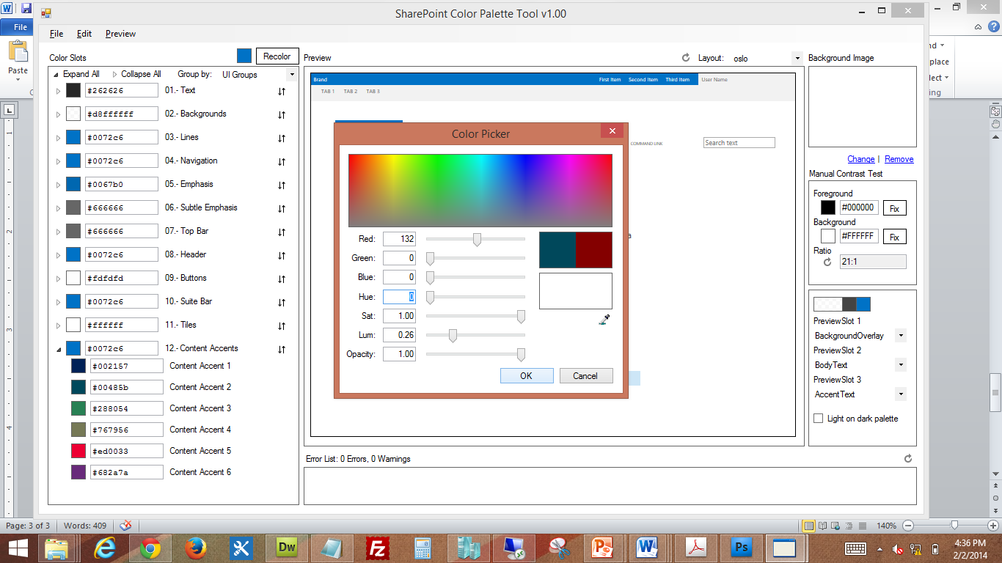

* 1. The color picker has converted the RGB to hex and the new color is now showing.

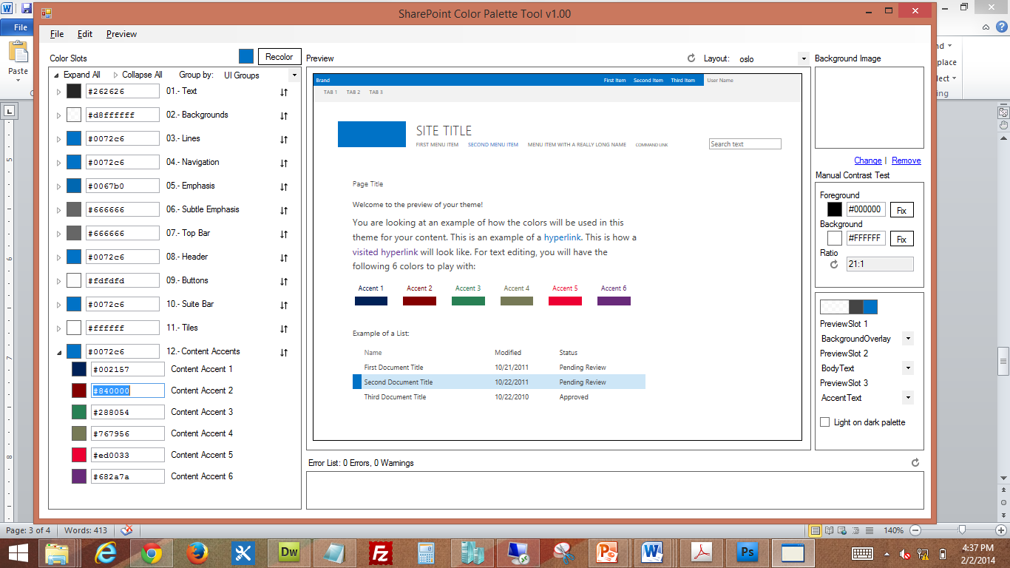

1. To finish modify the .spcolor file for our custom Composed Look, make the changes listed below.
   1. 12.- Content Accents
      1. Content Accent 3: #b1ceec
      2. Content Accent 4: #ead20b
      3. Content Accent 5: #02600f
      4. Content Accent 6: #000a1b
   2. 10.- Suite Bar
      1. Suite Bar Background: #e6002157
   3. 08.- Header
      1. Header Navigation Text: #002157
      2. Header Navigation Hover Text: #840000
      3. Header Navigation Pressed Text: #840000
      4. Header Navigation Selected Text: #840000
   4. 07.- Top Bar
      1. Top Bar Brackground: #4cb1ceec
   5. 03.- Lines
      1. Row Accent: #02600f
2. Go to **File** in the top left of the menu bar and select **Save**. Name your file **wingtip.spcolor** and save it to your desktop. After your file has been saved, a dialogue box will show confirming the successful creation of your file.

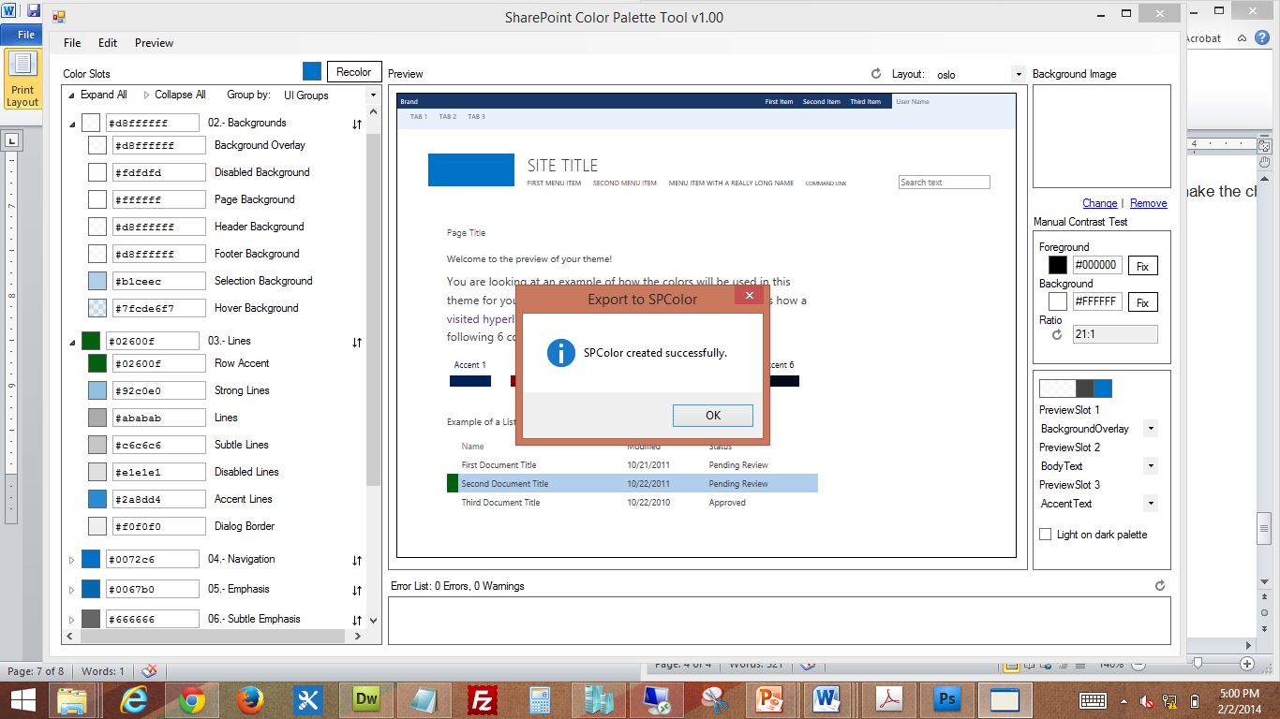

Be make sure you save often. If you close SharePoint Color Tool without saving it will NOT give you a warning that you are about to close the program on an unsaved file.

### Exercise 4: Create a Custom .spfont File

In this exercise you will create a custom .spfont file by downloading an OOB .spfont file and customizing it.

1. Open up <http://intranet.wingtip.com> in Internet Explorer.
2. In the **Site Actions** menu, select **Site Settings**.



1. Go to **Themes** under Web Designer Galleries.

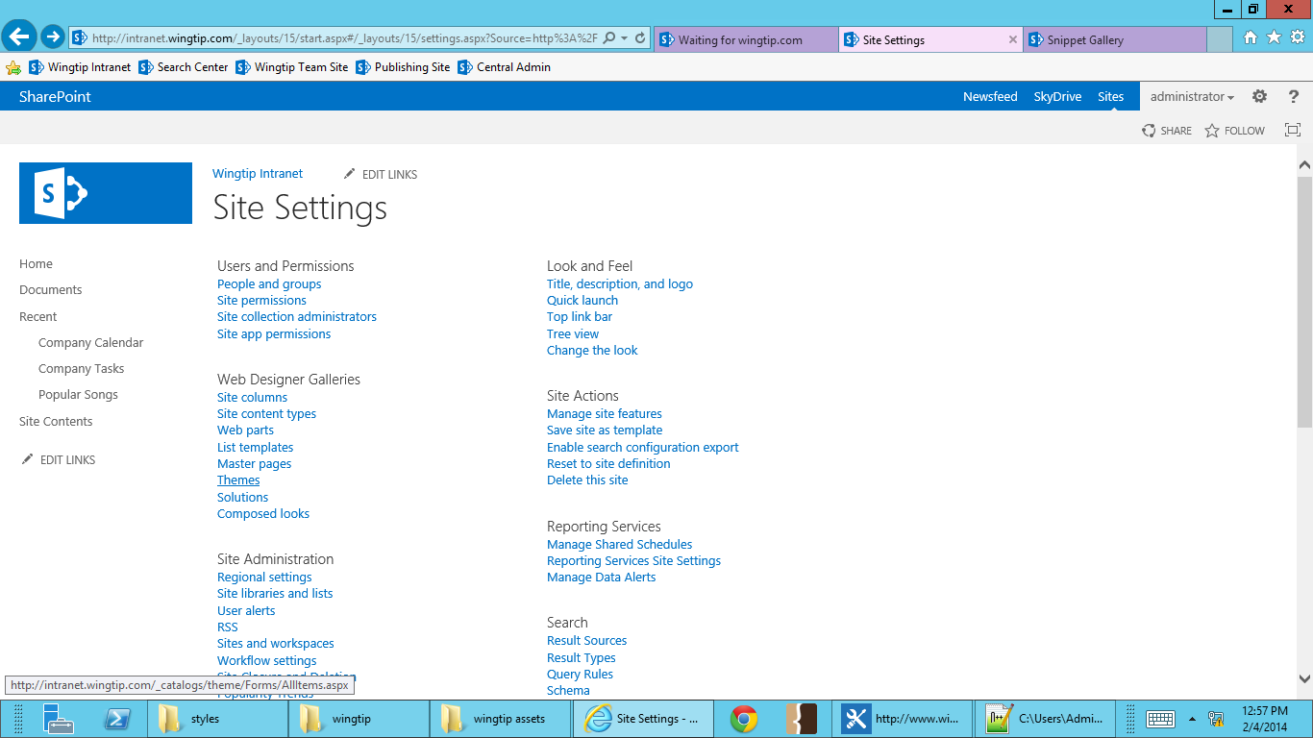

1. Go to the **15** folder.
2. Once there you’ll see files for font schemes and color palette. Since we’re creating an .spfont file, click on **fontscheme001** to download it. When the save dialogue box pops up, select **Save As** and save to your desktop.

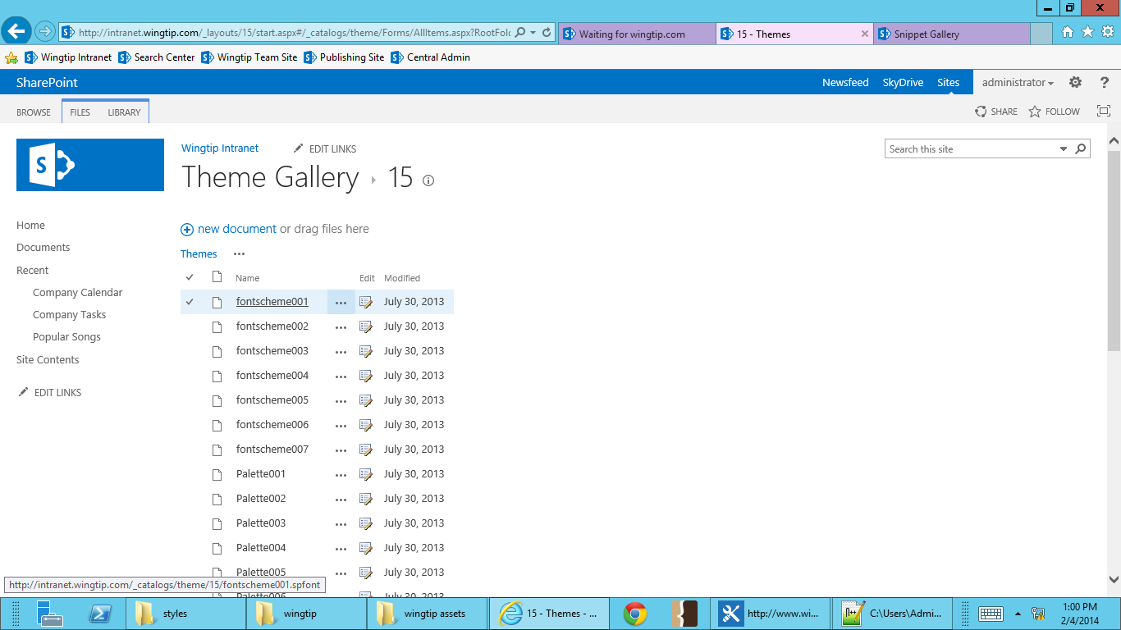

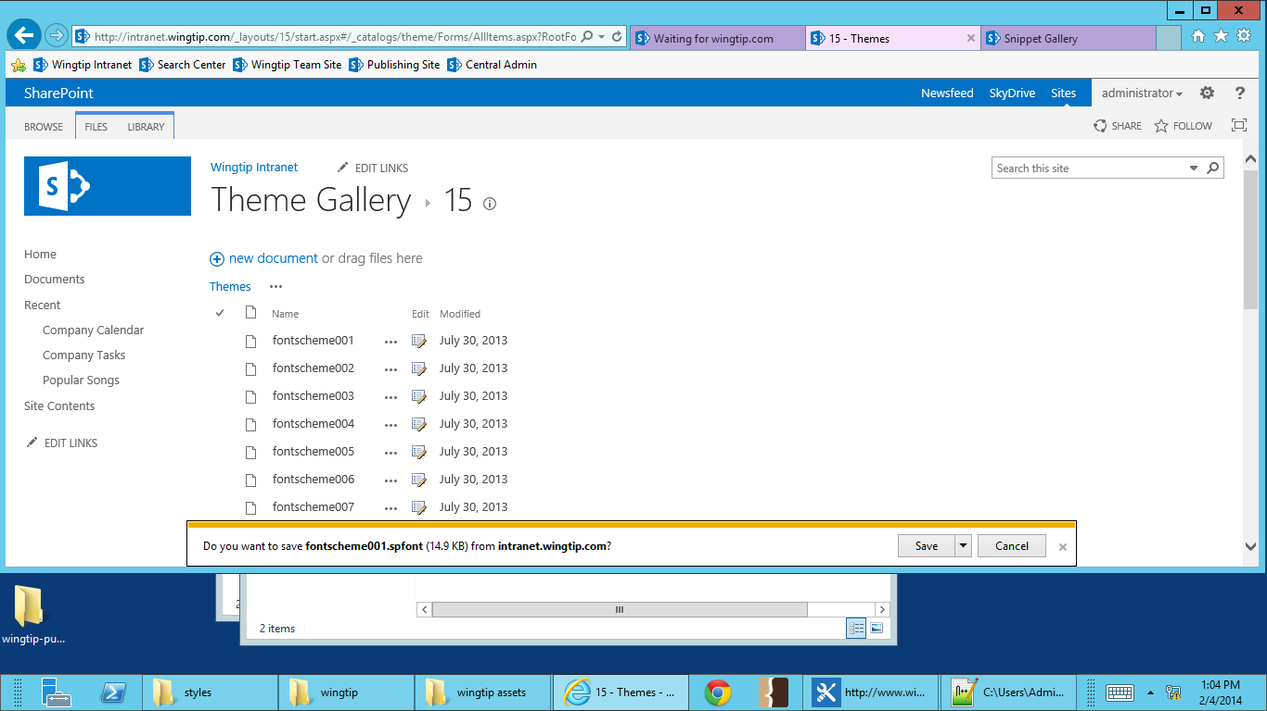

1. Go to your desktop and open **fontscheme001.spfont** with Notepad++ or your text editor of choice.
2. Find and replace **Segoe UI, Segoe UI Light and Segoe UI Semilight** with **Tahoma.**

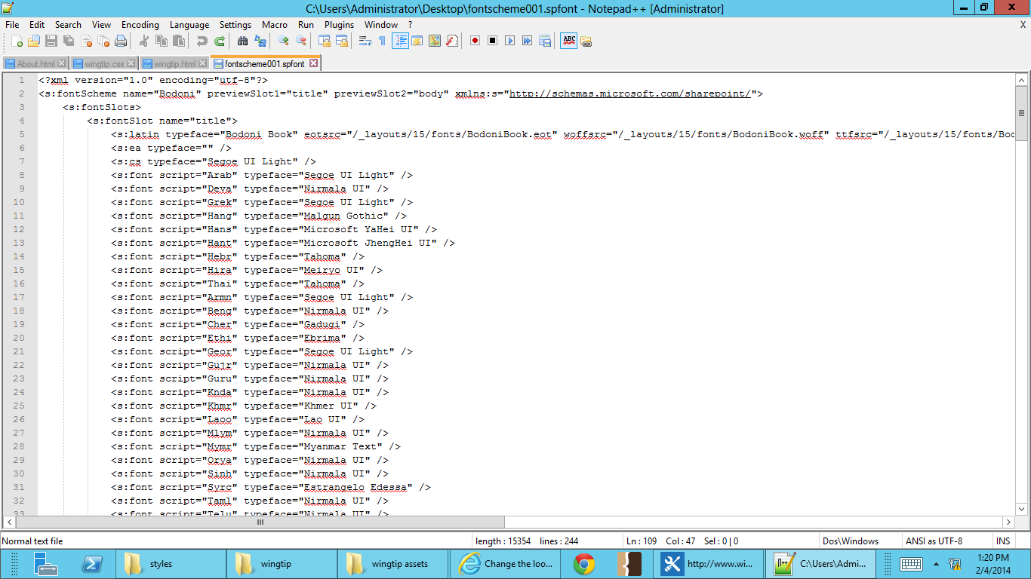

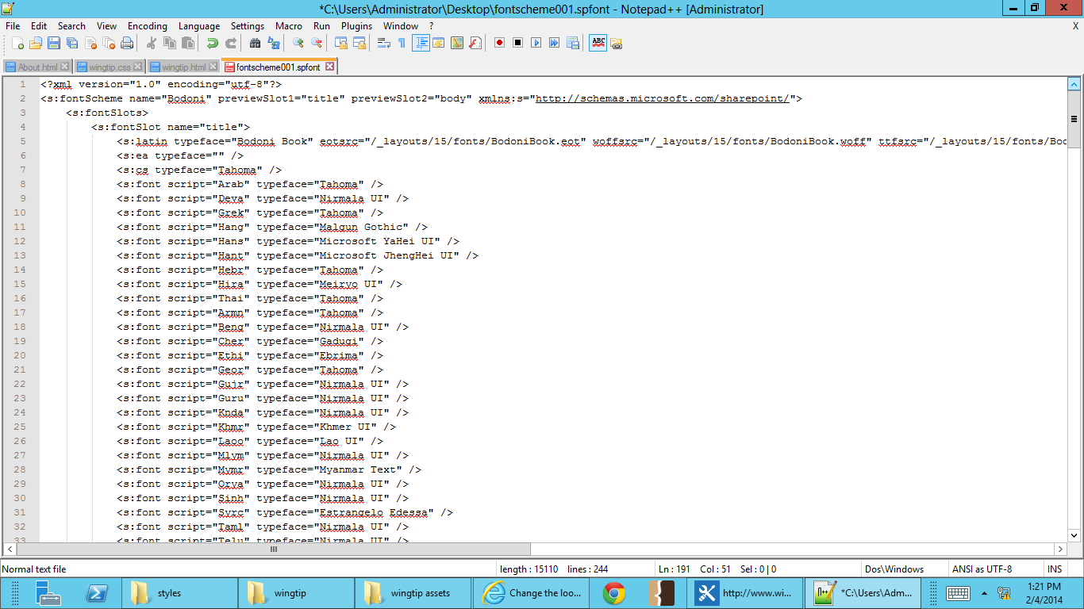

1. Go to **File**, **Save As** and save your file as **wingtip.spfont**.

### Exercise 5: Create a Custom Composed Look

In this exercise you will upload compile your custom .spcolor and .spfont file, and custom background image to create a fully branded composed look.

1. Open up <http://intranet.wingtip.com> in Internet Explorer.
2. In the **Site Actions** menu, go to **Site Settings**.



1. Go to **Themes** under Web Designer Galleries.



1. **Open your student files folder, find intranet-bg.jpg, and drag-and-drop it into tinto the Theme Gallery.**

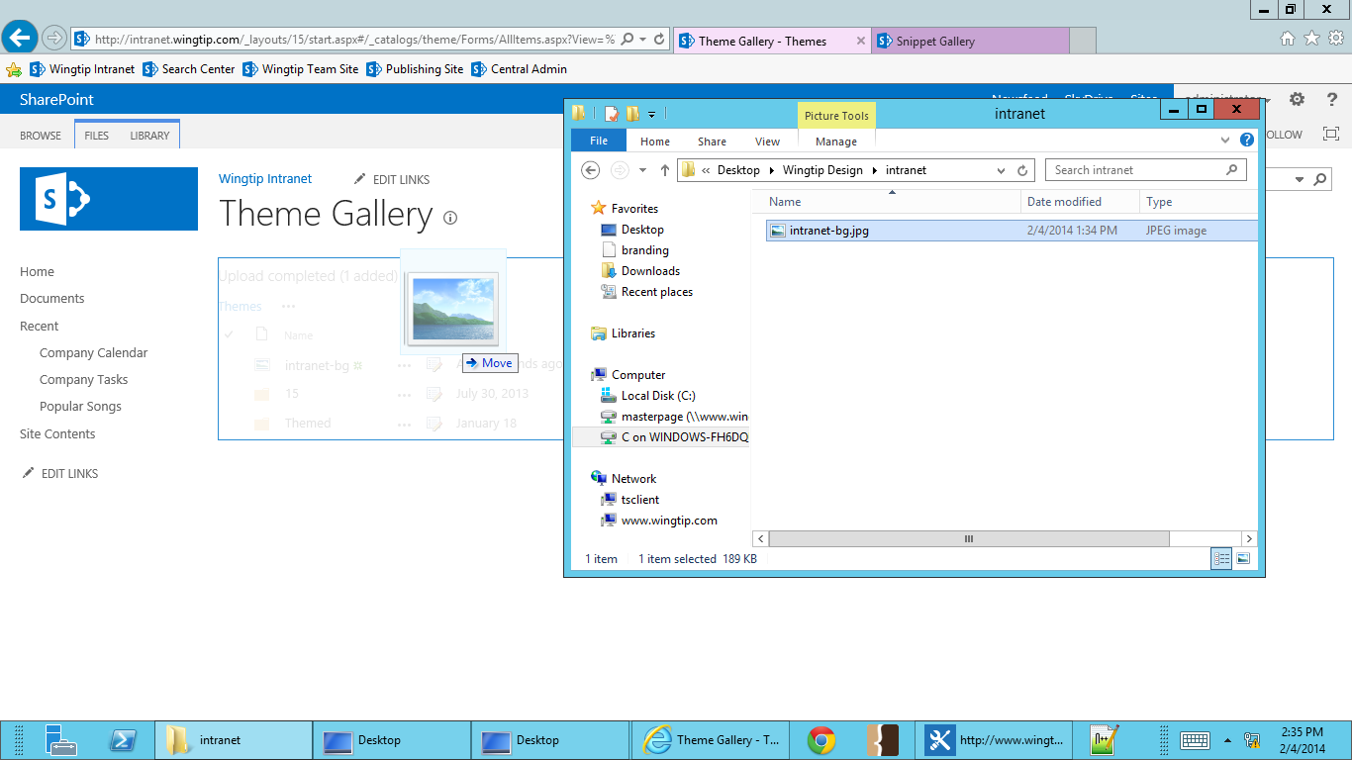

1. Go to the **15** folder.
2. Open **file explorer**, and browse to your **desktop**, select **wingtip.spcolor** and **wingtip.spfont**, and drag-and-drop it into the folder. This can also be done by selecting **Browse** and selecting files for upload.

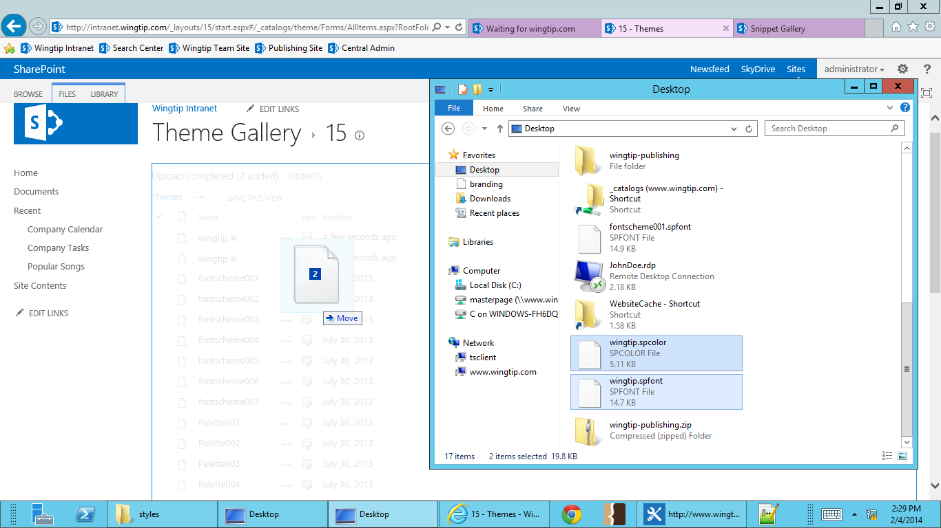

1. Go to **Site Actions**, and select **Site Settings**. Under Web Designer Galleries, select **Composed Looks**.

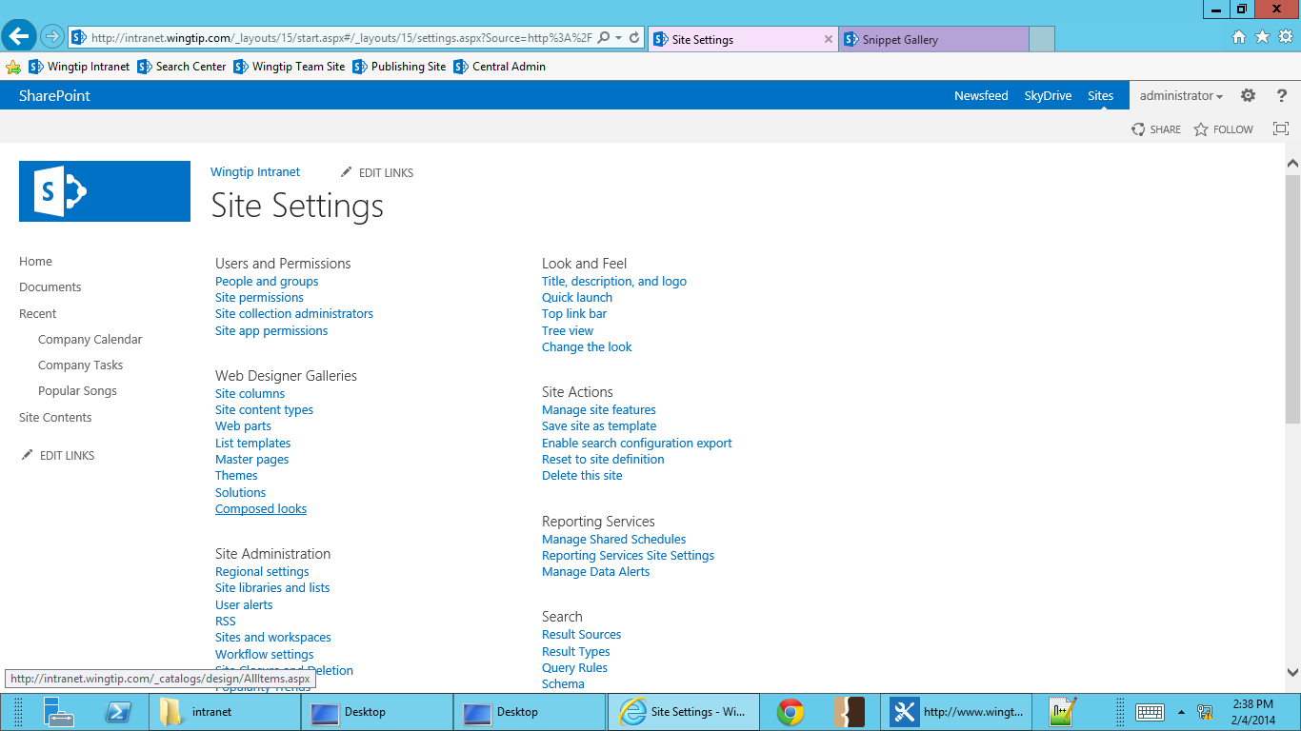

1. Select **New Item**.

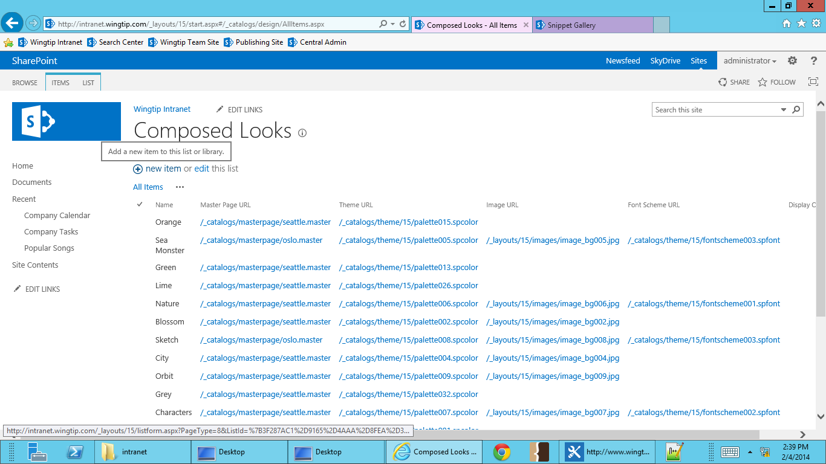

1. Fill in the fields with our custom image, .spcolor and .spfont, and use the Olso master. Select **Save**.
   1. **Title**: Wingtip
   2. **Name**: Wingtip
   3. **Master Page URL**: http://intranet.wingtip.com/_catalogs/masterpage/oslo.master
   4. **Theme URL**: http://intranet.wingtip.com/_catalogs/theme/15/wingtip.spcolor
   5. **Image URL**: http://intranet.wingtip.com/_catalogs/theme/intranet-bg.jpg
   6. **Font Scheme URL**: http://intranet.wingtip.com/_catalogs/theme/15/wingtip.spfont
   7. **Display Order**: 1

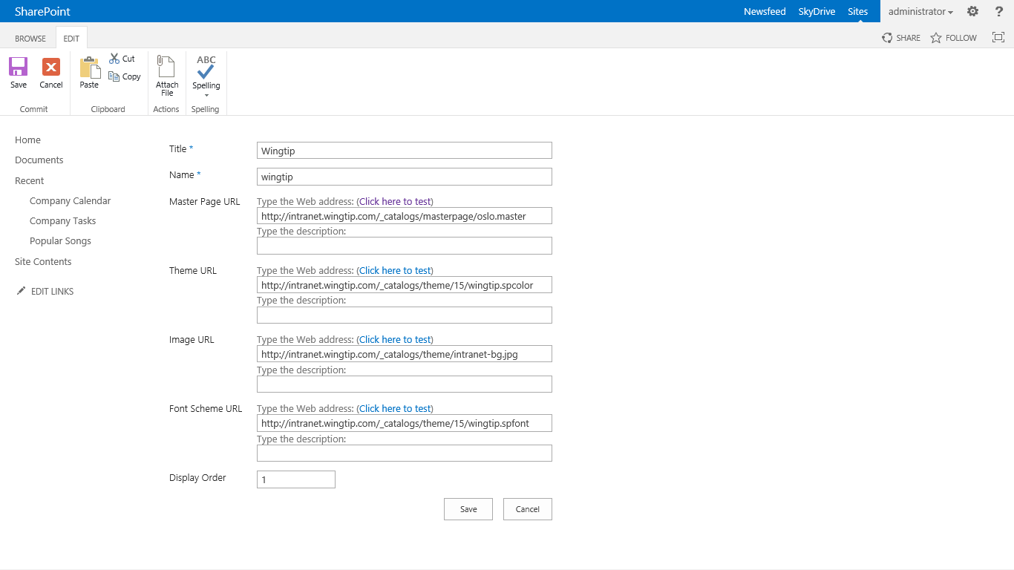

1. The new Composed Look as now been created.

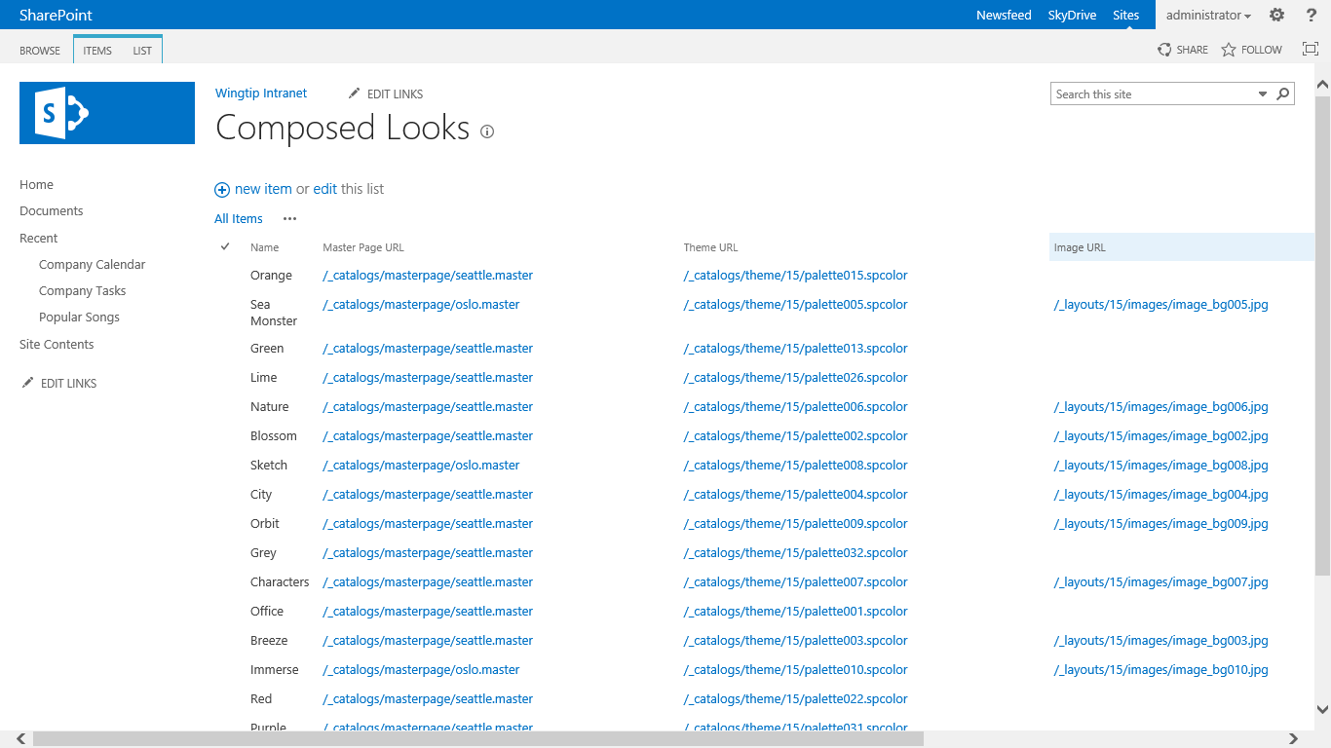

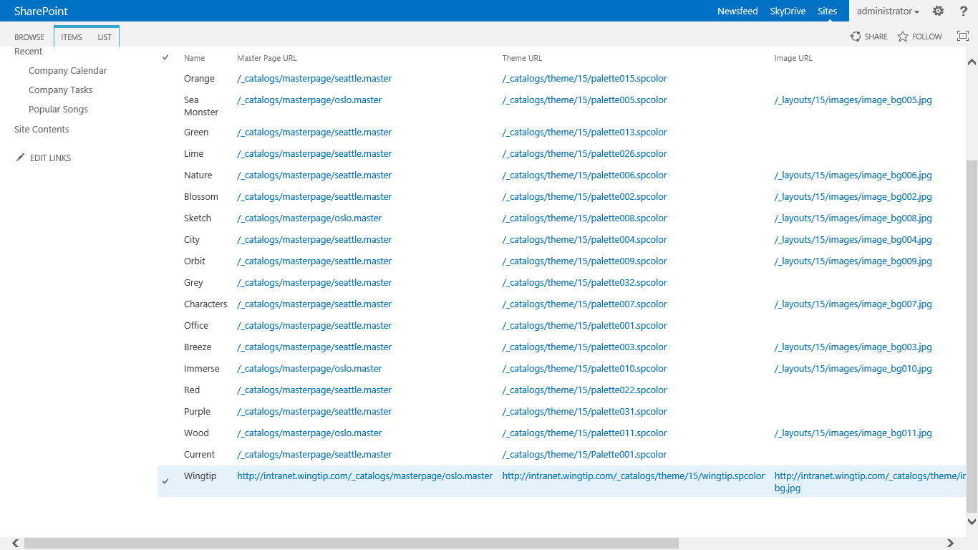

1. Go to **Site Actions** and select **Change the Look**.
2. Select **Wingtip** from the Composed Looks Gallery.

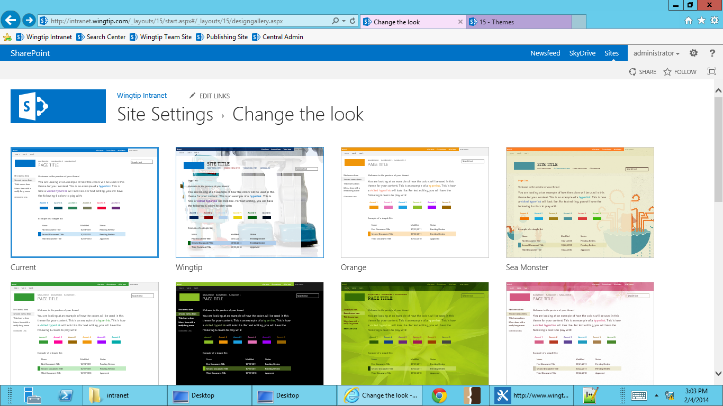

1. Select **Try it out**, then select **Keep it**.
2. Your custom composed look has now been applied to your site.

